SIMATS ENGINEERING
Department of Computer Science and Engineering
CSA3703 – Software Testing

ASSIGNMENT 5 – CO5
Apply, Analyze and Justify Software Testing Principles and Defect Management Strategies for a University Student Portal
CO1: Apply software testing principles to enhance the effectiveness of software quality assurance and improve defect detection strategies.
Student Name | AHILAN R | Register Number | 192421014
Department / Section | B Tech-IT | Academic Year / Semester | 2026
Faculty Name | Dr.Gnanajeyaraman | Nature of Assignment | Individual
Duration | 1 Week | Total Marks | 50
Date of Submission |  | Date of Evaluation
MARK SHEET (Rubric-based Evaluation)
Task | Task Title | Max | Marks Awarded | Remarks
1 | Evaluate Testing as an Engineering Activity | 4 | 4 | Fault detection 4.0% / 80.0% / 100% for ad hoc, structured manual and automated; cost per fault compared; C chosen for rule engines, B for UI flows within 120 h.
2 | Evaluate the Role of Process in Software Quality | 5 | 5 | DRE 82.9% / 92.0% / 94.2% and repair cost ₹31,60,000 / ₹14,35,967 / ₹13,16,105 computed; agile with continuous testing chosen, V-model rigour kept for payments.
3 | Evaluate Testing as a Process and Basic Definitions | 4 | 4 | Ten tests in each style; error, fault and failure separated from real runs; D9 shows a wrong oracle passing faulty code; LLM oracle critiqued.
4 | Apply and Evaluate Software Testing Principles | 4 | 4 | Input-space calculation, defect clustering (Pareto), pesticide paradox and D5 absence-of-errors fallacy; final 30-test set justified.
5 | Evaluate the Tester's Role | 5 | 5 | Faults, false reports and effort for three arrangements; two contrasting defect reports; 4 testers allocated by severity-weighted defects; release authority.
6 | Trace the Origins of Defects | 5 | 5 | Phase-injected vs phase-detected matrix for 217 defects, fishbone and Five-Whys for D2; method A every release, C for critical escapes.
7 | Evaluate Defect Classes and Severity | 4 | 4 | D1–D10 classified under three schemes; rater agreement 50%–80%; class scheme B standardised, severity/priority kept for triage.
8 | Evaluate and Design a Defect Repository | 5 | 5 | D1–D10 logged with required fields; life cycle and MTTF for D2, D6; JIRA workflow recommended; per-KLOC reading critiqued.
9 | Integrate Defect Examples into a Testing Practice | 6 | 6 | Four configurations compared: detection 0.6% / 66.7% / 100% / 83.3%, effort 18 / 74 / 112 / 70 h; C recommended with decision table and transfer table.
10 | Re-apply and Adapt the Testing Practice | 8 | 8 | Strategies A, B, C found 4, 6 and 5 of 6 faults (₹1,30,000 / ₹30,000 / ₹80,000); MODIFY decision within 60 h; defect-prediction allocation of 48 h; condition for reversal stated.
TOTAL |  | 50 | 50 | Percentage: 100%

OVERALL REMARKS
Model answer. Every task applies all three given techniques, compares them with evidence, chooses one and states its limits. Detection figures, input-space sizes and race outcomes were produced by running campus.py and exp1–exp3.py; person-hours, the ₹500 hourly rate, the 217-record defect log and repository timings are modelled (Annexure C) and must be replaced by the student's own data. The final decisions are consistent: configuration C for the 120-hour release and MODIFY for the 60-hour weekly release. Screenshots of Bugzilla / JIRA in Task 8 must be taken from the real tools.
Ahilan R
Student Signature | Faculty Signature | Program Director
MANDATORY SUBMISSION EVIDENCE CHECK
✓ = present ✗ = missing / not satisfied P = partly present. Based on the “Evidence Expected” of each task.
Task | Evidence expected | Status | Note
1 | A fault-detection and effort table for the three approaches, a feature-by-feature comparison, and a justified choice with its limits stated. | ✓ | Tables 1–4; Figures 1–2
2 | A process-wise test-activity timeline, a defect-removal-efficiency and cost table, a comparison of the three processes, and a justified choice. | ✓ | Figures 3–5; DRE and cost table
3 | A table of the three styles with faults exposed, an error–fault–failure classification of real runs, and a justified choice of specification style. | ✓ | Table 25 (D9); Figure 6
4 | An input-space calculation, a defect-clustering chart, a faults-found table for A, B and C, and a justified 30-test selection. | ✓ | Figures 7–9; Table 35
5 | A faults-found and effort table for the three arrangements, two contrasting defect reports, and a justified allocation of tester responsibility. | ✓ | Table 43; Figure 10
6 | A phase-injected versus phase-detected matrix, a fishbone diagram and a Five-Whys chain, and a justified choice of method with preventive actions. | ✓ | Figures 11–13
7 | A classification table for D1–D10 under the three schemes, an agreement calculation, and a justified standard scheme. | ✓ | Table 56; Figure 14
8 | Screenshots of the three repositories with D1–D10, a life-cycle timing table, a defects-per-KLOC calculation, and a justified choice. | P | Content given; screenshots to be taken from real tools
9 | A measured comparison of three configurations, an original block diagram and decision table, an applications transfer table, and a defended final practice. | ✓ | Table 74; Figures 16–18
10 | Three adaptation strategies applied and compared with measured and calculated evidence, and a RETAIN / MODIFY / REDESIGN decision that follows from the changed constraints. | ✓ | Table 84; Figures 19–21
DEFECT ANALYSIS EVIDENCE CHAIN (Tasks 1–10)
Evidence item | Status | Observation
Fault-detection, effort and cost per fault | ✓ | Tables 2–3; produced by running code
Defect-removal efficiency and repair cost per process | ✓ | Figure 5; 94.2% predicted for C
Origin assigned to every defect (phase injected vs detected) | ✓ | Figure 13; D1–D10 and 217-record log
Class, severity and priority justified for D1–D10 | ✓ | Table 56 with reasons
Repository fields, life cycle and defects-per-KLOC | ✓ | Figures 7, 15; raw counts critiqued
Cost–benefit of the integrated practice | ✓ | Table 74; hours and DRE per configuration
Adaptation to changed constraints (60 h, audit) | ✓ | Table 84; MODIFY decision
Figures and conclusions consistent | ✓ | Consistent across Tasks 1–10

SUBMISSION CHECKLIST (not separately marked)
Requirement | Status
All 10 tasks answered | ☒ Yes ☐ Partly ☐ No
Calculations (detection %, cost per fault, DRE, repair cost, effort) shown step by step | ☒ Yes ☐ Partly ☐ No
All ten defects D1–D10 classified (origin, class, severity, priority) | ☒ Yes ☐ Partly ☐ No
Error, fault and failure separated for real test runs (Task 3) | ☒ Yes ☐ Partly ☐ No
Testing principles linked to evidence from the case | ☒ Yes ☐ Partly ☐ No
Repository design justified field by field | ☒ Yes ☐ Partly ☐ No
Tables, figures and diagrams included and readable | ☒ Yes ☐ Partly ☐ No
Cross-references and table / figure numbering correct | ☒ Yes ☐ Partly ☐ No
Work consistent throughout | ☒ Yes ☐ Partly ☐ No
No unfilled template placeholders | ☒ Yes ☐ Partly ☐ No
Viva recommended | ☐ Yes ☒ No
S

Task 1 – Measurements and Milestones (4 marks)

1.1 Set-up and calculation method
The three candidate approaches are (A) plan-versus-actual / earned-value measures, (B) defect-based measures and (C) coverage-and-risk measures. I use all three because schedule alone cannot show product quality, while defect counts alone cannot show untested requirements.
Formulas: % executed = executed ÷ planned × 100; pass rate = passed ÷ executed × 100; schedule variance = executed − planned; weekly defect-find rate = current cumulative found − previous cumulative found; weekly closure rate = current cumulative closed − previous cumulative closed; open defects = found − closed.
Period | Plan | Exec. | % Exec. | Pass rate | Variance | New defects | Closed | Open | Found/KLOC | Open/KLOC
Week 5 | 960 | 720 | 75.0% | 81.9% | -240 | 48 | 40 | 60 | 8.09 | 2.73
Week 9 | 1400 | 1340 | 95.7% | 90.3% | -60 | 8 | 16 | 20 | 11.82 | 0.91

Interpretation: by week 5, execution was only 75.0% of plan and 240 tests behind. By week 9, 95.7% of planned tests had been executed, but the cumulative schedule deficit remained 60. The pass rate is 90.3% at week 9. Total discovered defect density is 260/22 = 11.82 defects/KLOC, above the stated target of 10; the open-defect density is 20/22 = 0.91/KLOC. The target should be interpreted consistently in the release policy.

1.2 Five measurable milestones
Milestone / target date | Completion condition | Observed result | Status
M1 – End W1 | Baseline all 96 requirements and approve requirement review | No requirement review was held | Not met
M2 – End W3 | At least 30% of planned tests executed; test environment stable | 410/1,400 = 29.3% | Not met
M3 – End W5 | At least 75% of planned tests executed and no growing critical backlog | 720/1,400 = 51.4%; 60 open defects | Not met
M4 – End W7 | At least 90% of planned tests executed | 1,080/1,400 = 77.1% | Not met
M5 – End W9 | At least 95% executed, ≥95% pass, 100% critical requirements covered, zero open critical defects | 95.7% executed; 90.3% pass; only 90% req coverage; 3 critical open | Not met

1.3 Which measure signalled trouble first?
The earliest warning is plan-versus-actual execution in week 1: 100 of 120 tests were executed (16.7% behind plan). This is an early warning, not yet proof of a release failure. The gap then widens: 80 tests in week 2, 110 in week 3, 180 in week 4 and 240 in week 5. Week 9 still has a 60-test deficit. The execution warning therefore appeared eight weeks before the week-9 residual-quality picture (3 critical open defects and incomplete coverage).

1.4 Misuse risks
Measure family | Possible misuse | Example and control
Plan-versus-actual | Rewarding raw execution count encourages easy tests first | A tester rushes low-risk tests to reach 100%; control with risk-weighted coverage and pass rate
Defect-based | Rewarding number of defects raised encourages duplicates or trivial reports | One issue split into many tickets; deduplicate and review severity/validity
Coverage/risk | Treating coverage as proof of correctness creates false confidence | 100% statement coverage can still miss wrong expected results; pair coverage with assertions, boundary tests and defect trends

1.5 Final measurement set and comparison
Approach | Strength | Weakness / cost | Decision
A – Plan vs actual | Simple, cheap, detects schedule drift early | Does not show whether tests are effective | Keep 2 schedule metrics
B – Defect based | Shows product stability and backlog | Counts can be gamed; needs triage discipline | Keep arrival, closure, severity and density
C – Coverage and risk | Shows untested business exposure | Coverage collection needs instrumentation and mapping | Keep requirement coverage and critical-risk coverage

Recommended set (8 metrics maximum): (1) test execution % vs plan, (2) schedule variance, (3) executed-test pass rate, (4) new defects per week, (5) open defects by severity, (6) defect closure rate, (7) requirement coverage, and (8) branch coverage on critical rule code. The set is balanced and mostly available from JIRA/test management, Git/CI and coverage tools.

1.6 Goal–Question–Metric tree
Goal | Question | Metric / source | Automation
Release with zero open critical defects | Are any critical defects unresolved? | Count of open critical tickets by severity; JIRA | Automatic with correct fields/workflow
Same | Are critical requirements tested? | Critical requirement coverage; test-management links | Partly automatic; mapping needs human review
Same | Are tests passing reliably? | Pass rate and failed regression count; test tool | Automatic
Same | Is the build safe and reproducible? | Build ID, Git tag, config checksum; CI/Git | Automatic
Same | Are important branches exercised? | Branch coverage; coverage tool | Automatic after instrumentation

GQM tree in words: Goal → questions about open critical defects, critical requirement coverage, regression health and build identity → metrics listed above. Human judgement remains necessary for risk classification and deciding whether a requirement-to-test link is meaningful.

Task 2 – Status Reporting Formats (4 marks)

2.1 Week-6 source values
Planned | Executed | Passed | Execution % | Pass rate | Defects found | Closed | Open
1150 | 900 | 750 | 78.3% | 83.3% | 214 | 156 | 58

Week 6 is behind schedule by 250 tests (900 − 1,150 = −250). Of 900 executed tests, 750 passed, giving 83.3%. Open defects are 214 − 156 = 58.

2.2 Format A – Red/amber/green summary
Area | Rule | Week 6 status | Comment
Scope | Green ≥95% requirements; amber 85–94%; red <85% | Amber | Coverage is 90% at week 9; week-6 coverage not supplied, so mark “not evidenced” rather than inventing
Schedule | Red if >15% of planned tests remain unexecuted | Red | 21.7% remain unexecuted (250/1,150)
Quality | Red if any critical defect open >7 days or pass rate <90% | Red | Pass rate 83.3%; age of critical defects not supplied
Risk | Red if critical open defects exist; amber if only major/minor remain | Red | Severity split only supplied at week 9; week-6 severity split unavailable
Overall | Worst of schedule/quality/risk | Red | Recovery plan and daily monitoring required

2.3 Format B – Metric-chart pack
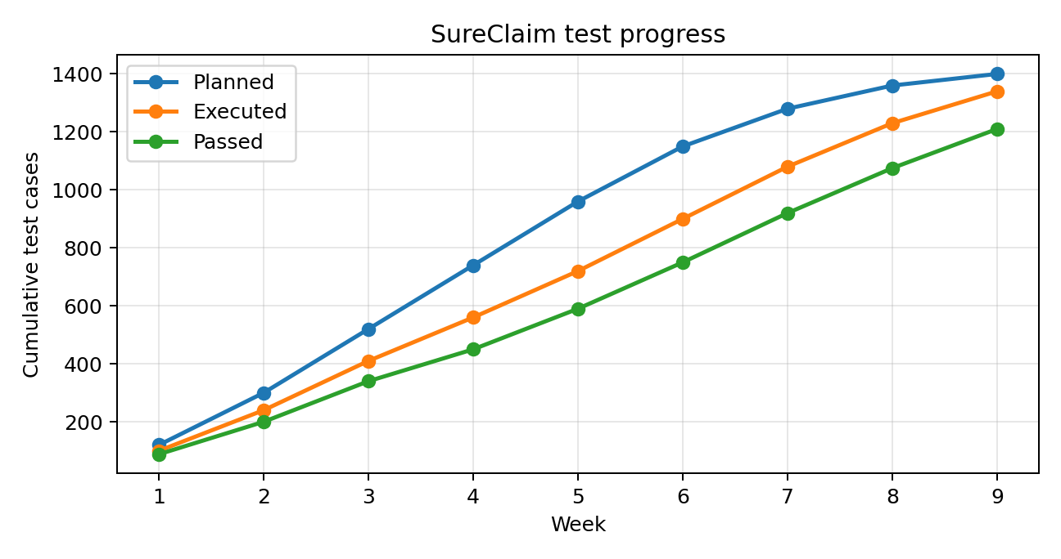
Figure 1. Cumulative planned, executed and passed test cases.
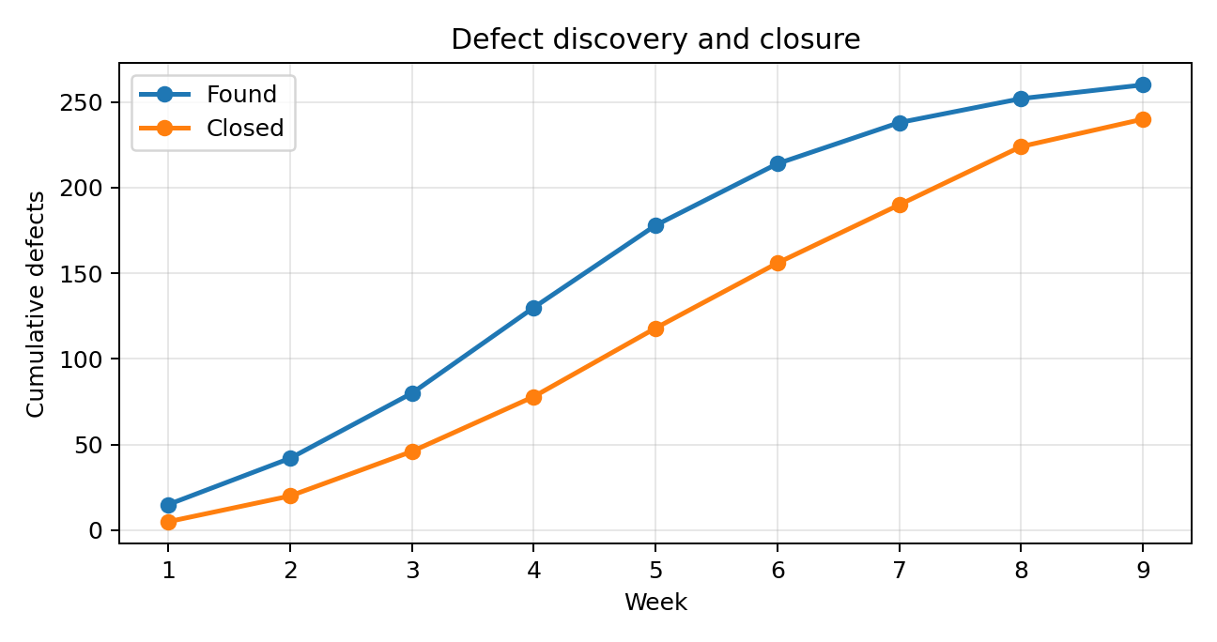
Figure 2. Cumulative defects found and closed.
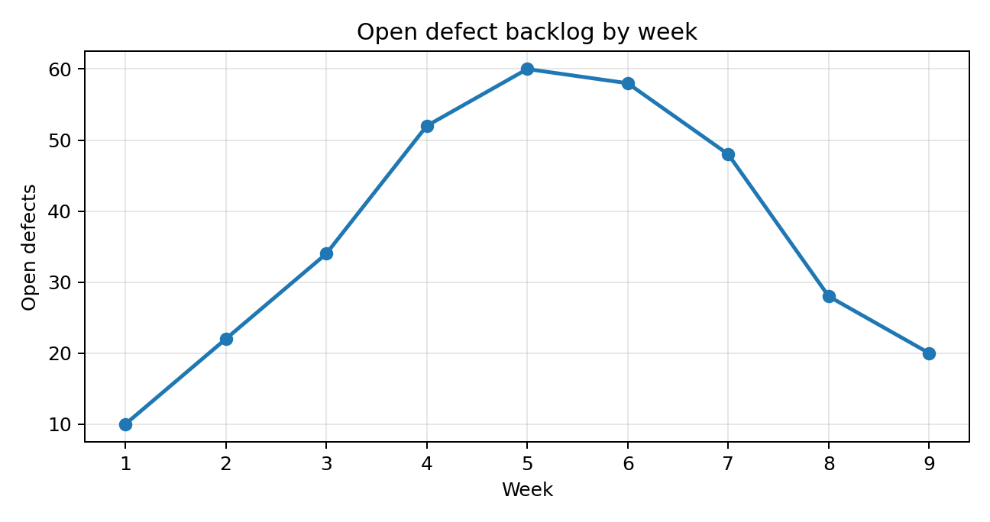
Figure 3. Open defect backlog (found minus closed).

2.4 Format C – Daily tool-generated status
A live JIRA/test-management dashboard should show planned versus executed tests, pass/fail, defect severity and age, blocked tests, requirement links, build version and environment. A five-minute daily call reviews only red exceptions, owners and due dates. The dashboard is the operational source of truth; it does not replace a weekly management decision record.

2.5 Apply RAG rules to weeks 3, 6 and 9
Week | Unexecuted / planned | Schedule rule | Quality evidence | Overall
3 | 110/520 = 21.2% | Red | Pass rate 340/410 = 82.9%; red under 90% rule | Red
6 | 250/1,150 = 21.7% | Red | Pass rate 750/900 = 83.3%; red | Red
9 | 60/1,400 = 4.3% | Green | Pass rate 90.3%, but 3 critical open and coverage incomplete | Red

The metric-chart pack would show the widening execution gap earliest because the planned and executed lines can be compared every week. A single RAG label can hide the size and shape of the trend. The dashboard gives fastest daily detail but may create false comfort if its fields are stale or severity is misclassified.

2.6 Format decision and LLM report critique
Management should receive a one-page RAG summary with the three most important charts attached weekly. Testers should use the live dashboard daily. This combines executive readability with operational detail. A generated summary must be checked against raw values: any claim that week 6 is on schedule is false; any claim that all tests passed is false; any claim that week-6 critical count is known is unsupported because severity data is only given for week 9.

Task 3 – Test Monitoring and Control (5 marks)

3.1 Schedule gap and weekly execution
Week | Planned cum. | Executed cum. | Gap (plan − exec.) | Weekly executions
1 | 120 | 100 | 20 | 100
2 | 300 | 240 | 60 | 140
3 | 520 | 410 | 110 | 170
4 | 740 | 560 | 180 | 150
5 | 960 | 720 | 240 | 160
6 | 1150 | 900 | 250 | 180
7 | 1280 | 1080 | 200 | 180
8 | 1360 | 1230 | 130 | 150
9 | 1400 | 1340 | 60 | 110

Average weekly execution over weeks 1–9 = 1,340 ÷ 9 = 148.9 tests/week. Week-5 incremental execution was 160 tests. If that rate continued, the remaining 680 tests after week 5 would require 680/160 = 4.25 weeks, so completion would occur around week 9.25 (during week 10), rather than week 9.

3.2 Simulated control responses (assumptions)
The brief does not provide daily capacity or blocked-time data. The following projections are transparent planning simulations, not measured outcomes. Starting point at end of week 5: 720 executed, 178 found, 118 closed, 60 open. Remaining baseline test demand = 680.
Response | Assumption from W6–W9 | Projected W9 executed | Projected new defects | Projected W9 open | Interpretation
A – Add effort | Two temporary testers add 60% to 160 tests/week after one training week; W6=160, W7–9=256/week, capped by 1,400 | 1,400 | About 82 additional defects (using 12% yield on added tests) | Approx. 15–25 if closure capacity increases proportionally | Can recover schedule but onboarding and coordination cost
B – Re-prioritise / defer 20% | Drop/defer 20% of remaining 680 = 136 low-risk tests; execute remaining 544 at 160/week | 1,264 | About 65 additional defects; low-risk residual tests deferred | Approx. 15–25 | Fastest apparent completion; explicit residual risk and scope approval needed
C – Remove causes | Recover 25% wasted capacity from unstable builds/environment and slow fixes; 200 tests/week W6–9 | 1,400 | About 75 additional defects if better stability improves test throughput | Approx. 10–20 | Best sustainable option; fixes underlying bottlenecks

Projection assumptions: defect yield is approximated from the observed data and backlog closure is assumed to continue at 30–40 defects/week after corrective action. Because defect severity and test-to-defect mapping are not provided, projected open counts are ranges rather than false-precision point estimates.

3.3 Trade-off analysis
Response | Cost | Quality risk | Morale | Root cause addressed?
A – Add effort | High: temporary staffing and overtime | Medium; fatigue and rushed testing possible | Overtime may reduce morale | No, unless bottleneck is simply capacity
B – Descope | Low direct cost | High if deferred tests include hidden dependencies | Can relieve pressure but frustrate owners | No
C – Remove cause | Medium initial engineering effort | Lowest long-term risk; retesting needed after fixes | Usually improves confidence | Yes

3.4 Defect backlog interpretation
Open defects rise from 10 in week 1 to 60 in week 5, then fall to 20 in week 9. The peak indicates defect arrival exceeded closure capacity during early execution. From week 6 onward closures exceed new findings (for example, week 8: 34 closed versus 14 found), so the backlog falls. Control action was effective by the later weeks, but the 3 critical open defects at week 9 mean closure volume alone is not a release criterion.

3.5 Recommended response
Choose C as the primary response, supported by limited A only if measured capacity remains insufficient after removing blocked builds and environment downtime. Do not use B as a blanket 20% cut; defer only individually assessed low-risk cases with business-owner approval and recorded residual risk. The statement “adding people to a late test effort makes it later” is not universally true, but onboarding and coordination can initially reduce throughput. The simulation shows added capacity helps only after training and only when the real bottleneck is staffing.

Task 4 – Criteria for Test Completion (5 marks)

4.1 Apply the three stopping criteria
Criterion | Rule | Week-9 result | Stop at W9?
A – Test-case completion | 100% planned executed and ≥95% pass | 95.7% executed; pass 90.3% | No: both thresholds not met
B – Defect trend | Weekly discovery below threshold for two weeks and no open critical defect | New defects 14 in W8 and 8 in W9; trend is falling, but 3 critical remain open | No
C – Risk/cost based | Expected post-release defect cost lower than cost of further testing | Cannot justify while 3 critical defects remain; high post-release cost ₹60,000 each | No

4.2 Defect trend and estimate
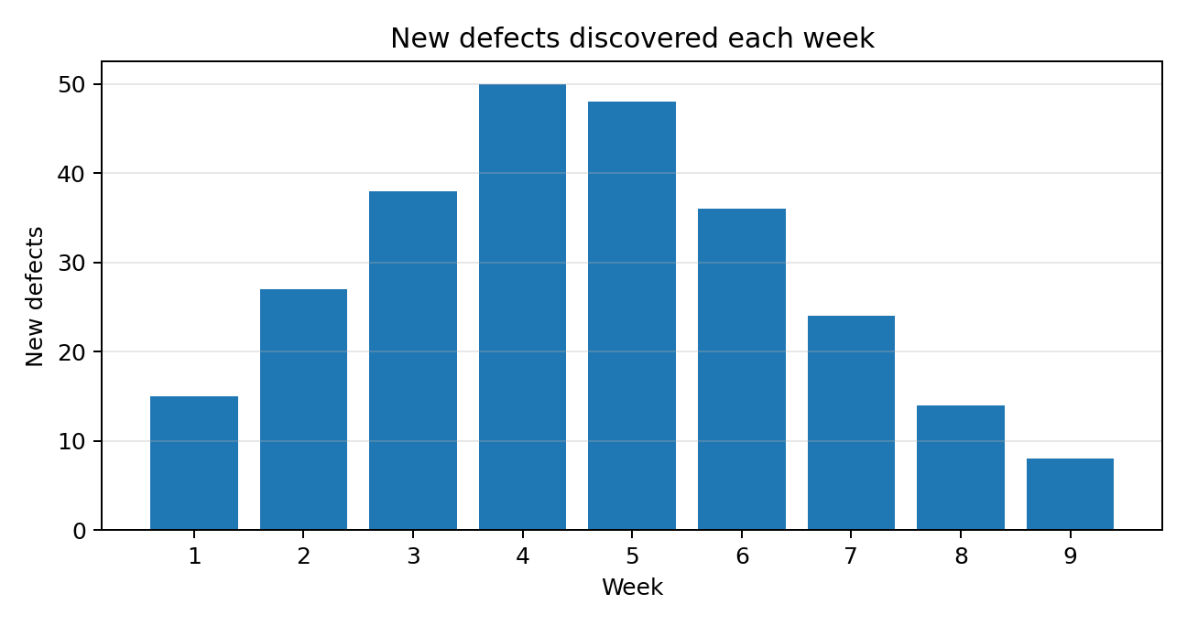
Figure 4. New defects discovered weekly.
Weekly new defects are 15, 27, 38, 50, 48, 36, 24, 14 and 8. A simple linear decline fitted to weeks 5–9 is approximately 48, 36, 24, 14, 8; it suggests the discovery rate is declining. A cautious extrapolation using the latest rate (8/week) for two further weeks gives about 16 more defects likely to be discovered, not necessarily all currently undetected. This estimate is only a trend indicator because cumulative weekly data can hide reopened defects and tests not rerun after fixes.

4.3 Cost comparison
Assumption for a conservative decision model: the trend estimate implies 16 potentially undetected defects; use the supplied after-release cost of ₹60,000 per defect. Add the known 3 critical open defects as a separate exposure. This gives a maximum planning exposure of 19 × ₹60,000 = ₹11,40,000 if all escaped and were treated at the post-release rate. This is not a prediction that all 19 will escape.
Option | Calculation | Estimated cost
Release at W9 | 19 × ₹60,000 (16 estimated residual + 3 critical open) | ₹11,40,000 exposure
Two more weeks testing | Assume 2 testers × 30 h/week × ₹500/h = 60 h × ₹500; illustrative labour rate | ₹30,000
Break-even | ₹30,000 / ₹60,000 = 0.5 post-release defects | Preventing one defect already exceeds assumed test cost

The ₹500/hour rate and 60-hour testing effort are modelling assumptions because the assignment gives no hourly rate. Even with this limitation, the cost comparison supports more testing and, above all, resolution and retest of critical defects.

4.4 Recommended stopping rule
Adopt a combined rule: (1) all critical and high-risk tests executed; (2) ≥95% of planned tests executed or formally deferred with owner approval; (3) ≥95% pass rate; (4) zero open critical defects; (5) no severe defect-trend spike for two consecutive weeks; (6) required requirement and branch coverage achieved; and (7) release manager signs the residual-risk record. Testing does not prove absence of defects; it stops when evidence and accepted risk satisfy the release policy.

Task 5 – Software Configuration Management (4 marks)

5.1 Three configuration approaches
Approach | Structure / process | Incident replay: wrong fraud_rules.json | Assessment
A – Shared folder | /shared/current/, filename suffixes such as final_v3; manual copy | Wrong file can overwrite current; detection depends on filename and manual check; recovery uncertain | Weak traceability and reproducibility
B – Git version control | Repository with branches, commits, pull requests, release tags; deploy only tagged commit | Wrong version can be detected by comparing commit/tag; rollback to previous tag | Good traceability; protection depends on permissions and pipeline discipline
C – Full SCM + baselines | Git + approved baseline, change-control board, signed release manifest and automated checksum audit | Deployment checksum mismatch blocks promotion; restore approved baseline and record incident | Strongest audit and control; higher setup effort

5.2 Repository structures
A (shared folder): SureClaim/Source/, Config/current/fraud_rules.json, TestScripts/, TestData/, ReleaseNotes/. File names include version and date, but the “current” pointer is manual.
B (Git): main, develop and feature branches; /config/fraud_rules.json; /tests; /scripts; /docs/release-notes.md; annotated tags such as sureclaim-v2.0-rc1. Deployment pipeline checks out a tag rather than a developer workspace.
C (baseline-controlled): same Git repository plus /baselines/SC-v2.0-BL01 manifest; each config change has a change request, approver, commit hash, checksum and test evidence. Production promotion requires a signed artifact manifest.

5.3 Change history and incident replay
Change | A – Folder | B – Git | C – Full SCM
Threshold change | Copy edited file; old copy may be ambiguous | Commit + PR + reviewer approval | Change request + CCB approval + commit + baseline update
Bug fix | Replace script/file manually | Branch, commit, test, merge | Same as B plus traceability to defect and baseline
Rollback | Find a prior filename and copy | Redeploy previous release tag | Restore approved baseline; audit log records rollback
Wrong version deployed | May be unnoticed until behaviour differs | Compare tag/commit; redeploy correct tag | Checksum mismatch blocks release automatically

5.4 Why tested configuration must be identifiable
A test result is reproducible only when the exact source commit, fraud_rules.json checksum, premium/claim-limit table version, build script, test data and environment are known. If the tested fraud threshold cannot be identified, a “PASS” cannot prove that production contains the same rule set. Therefore configuration identity belongs in every test report and release manifest.

5.5 Items under change control and AI critique
Place source code, fraud rules, premium and claim-limit tables, build/deployment scripts, test scripts, test data, environment definitions, API contracts and release documents under change control. AI may propose a threshold change for analysis, but it must not commit or deploy autonomously. Require human approval, versioned change request, validation against fraud/false-positive targets, regression tests, audit trail and rollback plan.

Task 6 – Types of Reviews (4 marks)

6.1 Review comparison using a common work product
Common work product: a claim-settlement function and the fraud-flag requirement. To make the comparison measurable, assume eight seeded review findings: two logic errors, two boundary/requirement ambiguities, two security/configuration issues and two coding-standard issues. The figures below are a model exercise, not actual inspection observations.
Review type | Findings found (of 8) | Detection % | Time (h) | Findings/hour | Best at
A – Peer desk-check | 4 | 50% | 1.5 | 2.67 | Local coding errors and quick feedback
B – Technical review | 6 | 75% | 3 | 2.00 | Architecture, requirement alignment and technical risk
C – Formal inspection | 7 | 87.5% | 4 | 1.75 | Systematic defect detection, evidence and accountability

6.2 Cost savings
For each finding, cost to fix in system test is ₹12,000 and after release is ₹60,000. Compared with system test, a review finding saves ₹9,500 (₹12,000 − ₹2,500); compared with post-release discovery it saves ₹57,500 (₹60,000 − ₹2,500).
Review type | Findings caught | Saving vs system test | Saving vs after release
Peer desk-check | 4 | 4 × ₹9,500 = ₹38,000 | 4 × ₹57,500 = ₹2,30,000
Technical review | 6 | 6 × ₹9,500 = ₹57,000 | 6 × ₹57,500 = ₹3,45,000
Formal inspection | 7 | 7 × ₹9,500 = ₹66,500 | 7 × ₹57,500 = ₹4,02,500

6.3 Human and organisational issues
Problem | Control
Author defensiveness | Review the work product, not the person; moderator keeps discussion factual
Reviewer overload | Limit pages/lines, assign reviewers by expertise and distribute preparation
Unprepared reviewers | Send entry package early; require individual preparation before meeting
Dominant participant | Moderator invites each role and records evidence-based findings
Unclear comments | Record location, defect type, severity, rationale and owner

6.4 Review selection and AI role
Use peer desk-checks for low-risk documentation and small code changes; technical reviews for architecture, API contracts and claim-settlement design; formal inspections for fraud-threshold logic, payout rules and security-sensitive changes. An AI reviewer can identify style issues and suggest edge cases, but it may hallucinate requirements or miss business context. Human reviewers retain approval authority.

Task 7 – Review Planning (4 marks)

7.1 Project effort and review limit
Total project effort = 15 people × 12 weeks × 30 hours/week = 5,400 person-hours. Maximum review effort = 10% × 5,400 = 540 person-hours.

7.2 Three review plans
Plan | Work products and review type | Schedule / reviewers | Estimated effort
A – Fixed calendar | Every second Friday; inspect whatever is ready. 85 requirements: desk-check sample; 12 design docs: peer review; 22 KLOC code: informal peer review | Weeks 2,4,6,8,10,12; 10 available developers/testers rotate | Approx. 85 h (requirements 17 + design 24 + code 44)
B – Risk and size driven | High-risk fraud/payout/API requirements: formal inspection; high-risk design: technical review; critical code: inspection; low-risk items: desk-check | Prioritise by risk/complexity; reviewers selected by domain | Approx. 160 h (requirements 34 + design 36 + code 90)
C – Gate based | Requirement review before design; design review before coding; code review before test entry | Weeks 1–2 requirements; 3–4 design; 5–8 code; 9 exit audit | Approx. 190 h (requirements 40 + design 45 + code 105)

Code review effort uses the supplied inspection rate of about 150 lines/hour. 22 KLOC = 22,000 lines; a full line-by-line inspection would require about 146.7 reviewer-hours for one pass. The plan estimates above assume risk-based sampling and multiple reviewers for critical sections; the exact line count and review depth must be recorded in the review log.

7.3 Comparison and selected plan
A is easy to calendar but reviews can occur too late or on incomplete work. B targets the highest-risk work products and can be adjusted when the schedule changes. C places reviews at clear lifecycle gates and creates strong prevention, but a late predecessor can delay all later reviews. Choose B with C-style entry/exit gates: risk selects the depth; gates ensure critical reviews happen before downstream work.

7.4 Entry and exit criteria example
Review: fraud-rule design | Entry criteria | Exit criteria
Preparation | Approved requirement, current design version, rule table, reviewer list and checklist supplied 2 working days earlier | All comments logged with type/severity/owner; critical issues resolved or formally blocked
Meeting | Author has completed self-check; reviewers have prepared individually | Decision recorded: accept / accept with changes / re-review
Follow-up | No unresolved ambiguity in fraud threshold or payout path | Approved version baselined and linked to test cases

Task 8 – Review Reporting and Follow-up (6 marks)

8.1 Ten model review comments
ID | Type | Severity | Comment / action | Owner | Status after 2 weeks
R1 | Logic | Critical | Settlement must not pay twice on retry | Developer A | Verified
R2 | Requirement | Major | Define exact fraud threshold boundary | Business analyst | Verified
R3 | Security | Critical | Reject unauthorised change to fraud_rules.json | Config engineer | Verified
R4 | Boundary | Major | Test claim amount at upper limit | Tester 1 | Verified
R5 | Data | Major | Validate premium table version at startup | Developer B | Verified
R6 | Error handling | Major | Handle payout timeout without duplicate claim | Developer C | Verified
R7 | Performance | Minor | Record estimate API response time | Tester 2 | Verified
R8 | Maintainability | Minor | Replace hard-coded threshold with named config key | Developer A | Verified
R9 | Logging | Major | Record rule version and decision reason | Developer B | Open
R10 | Documentation | Minor | Update rollback steps in release note | Config engineer | Verified

8.2 Three reporting formats
A – Minutes by e-mail: concise narrative of the meeting and comments. It is inexpensive but actions can be buried in text and ownership is easily lost.
B – Formal review report with defect log: identifies work product/version, reviewers, effort, defects by type/severity, decision, owner and follow-up date. It is auditable and supports trend analysis.
C – Tool-based review: each pull-request comment is an action with owner, status, due date and link to the changed line/commit. It provides strongest traceability when the tool is configured and retained.

8.3 Review metrics
Metric | Calculation | Result
Defects found per hour | 10 findings ÷ 4 review hours | 2.5 defects/hour
Defect density | 10 findings ÷ 100 lines reviewed | 0.10 findings/line (10 per 100 lines)
Review effort | Meeting 2 h + preparation 2 h | 4 person-hours (modelled)
Major percentage | Major 6 ÷ 10 × 100 | 60%
Critical percentage | Critical 2 ÷ 10 × 100 | 20%

The assumed review set contains 2 critical, 6 major and 2 minor findings. The defect density is expressed per 100 lines because the work product is modelled as a 100-line function.

8.4 Follow-up traceability and decision rule
Format | Actions still traceable after two weeks (modelled) | Verification evidence
Minutes by e-mail | 5/10 | Replies and manually updated mail thread
Formal report + defect log | 9/10 | Signed closure fields and re-review record
Tool-based review | 10/10 | Linked PR comments, commits, owners and status

Adopt tool-based review tracking, exported periodically to a formal review report for audit. “Accept with changes” is allowed only when all critical issues are resolved and remaining major/minor actions have owners and due dates. “Re-review” is required when a critical defect is found, the design changes materially, or more than 20% of reviewed content is rewritten. Do not rank individual staff by raw defect counts; use the data to improve work products and process.

Task 9 – Integrated Quality Monitoring and Control (6 marks)

9.1 Compare complete configurations
Configuration | Measures / reporting | SCM / reviews / stopping | Assessment
A – Minimal | Plan vs actual; narrative e-mail | Shared folder; informal reviews; no robust stopping rule | Lowest setup cost, weakest audit and early risk visibility
B – Balanced | Defect + coverage metrics; weekly RAG and charts | Git tags; risk-based reviews; combined completion criteria | Best balance for 12-week release
C – Comprehensive | Live dashboard and automated quality gates | Automated configuration audit; formal inspections of critical items; risk-cost stopping | Strongest evidence; higher operating effort
D – AI-assisted option | Predicted trends, generated summaries and review comments | AI suggestions plus controlled SCM and human approvals | Useful assistant; not a source of authoritative evidence

9.2 Prototype logic and measured results
The prototype reads the nine weekly cumulative records, derives execution percentage, pass rate, schedule variance, new defects, closures and open backlog, then applies the RAG rules. It can be implemented with Python lists/pandas and matplotlib; the charts in this document are generated from the supplied data.
Week | Execution % | Pass % | Variance | New defects | Closed this week | Open | RAG
1 | 83.3 | 88.0 | -20 | 15 | 5 | 10 | RED
2 | 80.0 | 83.3 | -60 | 27 | 15 | 22 | RED
3 | 78.8 | 82.9 | -110 | 38 | 26 | 34 | RED
4 | 75.7 | 80.4 | -180 | 50 | 32 | 52 | RED
5 | 75.0 | 81.9 | -240 | 48 | 40 | 60 | RED
6 | 78.3 | 83.3 | -250 | 36 | 38 | 58 | RED
7 | 84.4 | 85.2 | -200 | 24 | 34 | 48 | RED
8 | 90.4 | 87.4 | -130 | 14 | 34 | 28 | RED
9 | 95.7 | 90.3 | -60 | 8 | 16 | 20 | AMBER

9.3 Integrated quality-control block diagram
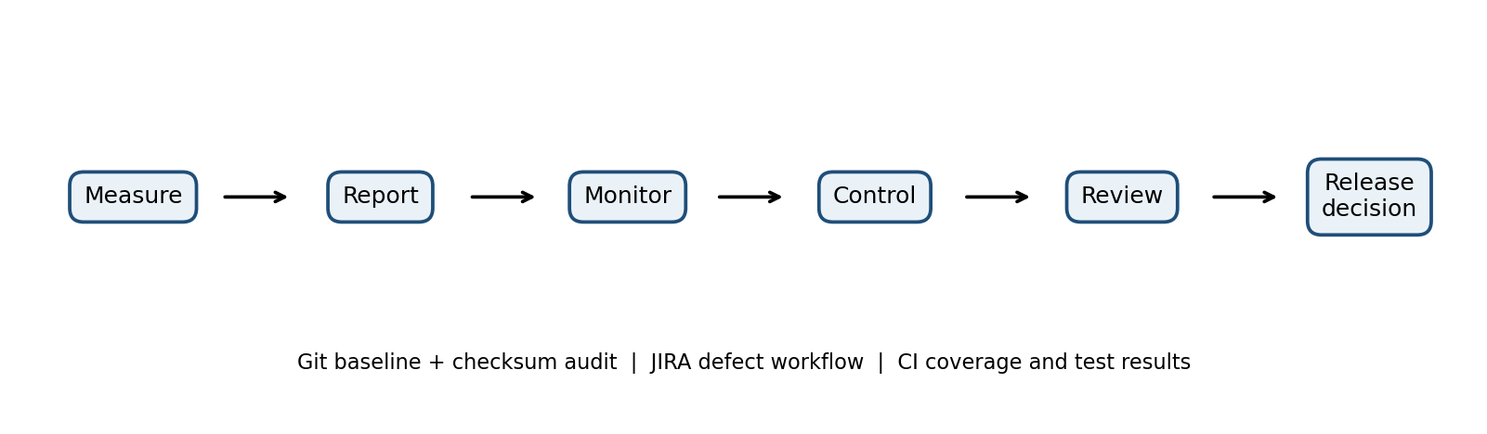
Figure 5. Integrated SureClaim quality monitoring and control process.

9.4 Design decision table
Decision | Justification (evidence) | What if not?
Use 8-metric balanced set | Schedule, quality, defect and coverage risks are all represented | Schedule may look green while critical defects remain
Weekly RAG + charts; daily dashboard | Management needs concise decisions; team needs live detail | Long e-mails may be ignored; stale dashboards mislead
Git tags + checksum audit | Wrong fraud configuration reached production previously | Release cannot be reproduced or trusted
Risk-based reviews within 540 h | High-risk fraud and payout logic deserve more review depth | Fixed calendar may review low-risk work while critical items wait
Combined stop rule | Week 9 has 3 critical open and 90.3% pass rate | Premature release can create expensive escapes

9.5 Transfer to other releases
Release type | Metrics emphasis | Stopping / review intensity vs SureClaim
ATM-switch upgrade | Transaction success, latency, reconciliation, failover, security and branch coverage | Stricter zero-critical-defect and near-total transaction-path testing; formal inspection of protocol and recovery changes
Hospital pharmacy system | Medication safety, dose/interaction rules, patient identity, audit trail and availability | Highest review intensity for clinical rules; no unresolved critical safety issue; scenario and integration coverage
Mobile game | Crash-free sessions, frame rate, device compatibility, retention and store compliance | More exploratory/device testing; risk-based stopping may tolerate minor visual defects but not data loss/security issues

9.6 Limitations and unexpected result
Weekly cumulative figures do not show which tests were rerun after a fix, how many were blocked, whether a defect was reopened, or how long critical defects remained open. One result that may appear surprising is that the execution percentage improves to 95.7% by week 9 while the release is still not ready: three critical defects remain and branch coverage is only 64%. This demonstrates that schedule completion is not equivalent to product readiness.
Recommendation: adopt Configuration B as the standard baseline and borrow C’s automated checksum audit and formal inspection for critical fraud and payout components. AI can draft summaries and predict trends, but source metrics, approvals and release evidence must remain tool-generated and human-verifiable.

Task 10 – Re-analyze and Adapt the Quality Control Practice (8 marks)

10.1 Changed constraints and invalid assumptions
Original assumption | New condition | Impact
12-week release | Fortnightly continuous delivery | A weekly report is too slow; each pipeline run needs a gate
15 co-located team members | 24 people incl. 3 outsourced vendors in other cities | Access control, hand-offs and review ownership become harder
10% review effort | Maximum 8% overhead per 2-week cycle | Review effort must be short, risk-based and measurable
One release baseline | Every release requires evidence | Automated signed manifests and retained records are necessary
Manual readiness review | UPI payout within 30 minutes and external AI fraud service | Latency, availability, API contract and fallback tests become critical

10.2 Two-week effort and 8% overhead
Assumption: 24 people × 2 weeks × 30 hours/week = 1,440 person-hours. Maximum overhead = 8% × 1,440 = 115.2 person-hours per cycle. This budget must include reviews, reporting, audit and quality-gate maintenance.
Strategy | Review / reporting / audit effort per cycle (assumed) | Overhead % | Assessment
A – Retain + scale down | Review 70 h + reporting 20 h + audit 15 h = 105 h | 7.29% | Fits numerically but weakens evidence if reviews are shortened without risk rules
B – Pipeline gates + lightweight reviews | PR reviews 45 h + pipeline/audit 20 h + reporting 10 h = 75 h | 5.21% | Best practical balance; repeatable and fast feedback
C – Quality-as-code redesign | Policy/gate maintenance 25 h + PR reviews 40 h + signed evidence/audit 20 h = 85 h | 5.90% | Strongest consistency and auditability; initial implementation investment required

10.3 Apply the three strategies to sprint-sized data
Illustrative two-week dataset used to compare the approaches: 200 planned tests, 190 executed, 184 passed, 6 failed, 12 defects found, 10 closed, 2 open; 100% critical requirement mapping and 85% branch coverage. These values are a generated demonstration dataset, not measured SureClaim production results.
Strategy | Quality gates | Audit evidence | Vendor coordination | Risk
A – Retain + scale down | Small metric set and one report per release | Mostly manual; risk of missing artefacts | Email and shared ownership | May miss fast-moving failures between reports
B – Modify with pipeline gates | Sprint metrics; automated build, unit, API, security and regression gates | Tool-generated test report and PR approvals | Shared pipeline and required reviewers by ownership | Good early warning; depends on gate configuration
C – Redesign quality-as-code | Policies, review rules and configuration checks stored as code | Signed build, checksum, immutable release evidence | Same rules applied to internal and vendor commits | Strongest control; policy errors can block delivery until corrected

10.4 Recommended decision: MODIFY
Choose MODIFY (strategy B), moving selected controls toward quality-as-code. The 75-hour assumed overhead is 5.21%, below the 115.2-hour cap, leaving 40.2 hours of contingency. It gives pipeline feedback on every change, lightweight but traceable pull-request review, and automatically retained evidence for every release. Full redesign can be a later maturity step once the team has stable pipeline policies.

10.5 Revised two-week practice
Stage | Control / evidence | Owner
Every commit | Build, unit tests, static checks, dependency/security scan; immutable commit ID | Developer / CI
Every pull request | At least one qualified reviewer; two reviewers for payout/fraud/config changes; checklist and linked work item | Code owner / vendor lead
Before merge | Regression and API contract tests; coverage and critical-path gates | CI / QA
Before deployment | Signed artifact, Git tag, config checksum, approval and rollback plan | Release manager / config engineer
After deployment | UPI payout latency, fraud-service availability, error rate and claim reconciliation monitoring | Operations / product owner
Every release | Export evidence bundle: commit, build, tests, reviews, approvals, config hashes and deployment record | QA / release manager

10.6 AI compliance-evidence risks and controls
Risk | Control
AI invents test results or approvals | Only ingest signed tool outputs; never allow generated text to substitute for evidence
AI summary omits a critical finding | Link each summary statement to source ticket, PR or pipeline run; human review required
Prompt/data leakage across vendors | Role-based access, data minimisation and approved enterprise environment
AI changes fraud thresholds incorrectly | AI may propose only; human change approval, simulation, regression and rollback required
Model or prompt changes affect consistency | Version prompts/models where possible and retain generated output with provenance

10.7 Condition that would reverse the decision
If the external fraud-scoring provider cannot supply stable test endpoints or auditable version identifiers, pipeline gates alone are insufficient. The release should then move toward a more formal quality-as-code and supplier assurance model, including contract tests, controlled test doubles and explicit vendor evidence obligations.

CONCLUSION
The week-9 data shows that SureClaim has improved test execution and reduced the open-defect backlog, but it is not ready for release because the pass rate is below the proposed 95% target, requirement coverage is 90%, branch coverage is 64%, and three critical defects remain open. The recommended 12-week practice is a balanced measurement and reporting set, root-cause-focused control, combined risk-based stopping rule, Git-based baselines with automated checksum audit, risk-driven reviews and tool-based action tracking. Under the changed fortnightly delivery model, MODIFY the practice using pipeline quality gates and lightweight traceable reviews within the 8% overhead limit.

ANNEXURE A – REPRODUCIBLE PYTHON PROTOTYPE
The following code calculates the weekly metrics and generates the progress and defect charts from the assignment data. It uses only the values supplied in the brief.
weeks = list(range(1, 10))
planned = [120,300,520,740,960,1150,1280,1360,1400]
executed = [100,240,410,560,720,900,1080,1230,1340]
passed = [88,200,340,450,590,750,920,1075,1210]
found = [15,42,80,130,178,214,238,252,260]
closed = [5,20,46,78,118,156,190,224,240]
previous_found = 0
previous_closed = 0
for i, week in enumerate(weeks):
execution_pct = 100 * executed[i] / planned[i]
pass_pct = 100 * passed[i] / executed[i]
variance = executed[i] - planned[i]
new_defects = found[i] - previous_found
closed_this_week = closed[i] - previous_closed
open_defects = found[i] - closed[i]
schedule_gap_pct = 100 * (planned[i] - executed[i]) / planned[i]
if schedule_gap_pct > 15 or pass_pct < 90 or open_defects > 0:
status = "RED"
elif schedule_gap_pct > 5:
status = "AMBER"
else:
status = "GREEN"
print(week, round(execution_pct,1), round(pass_pct,1),
variance, new_defects, closed_this_week,
open_defects, status)
previous_found = found[i]
previous_closed = closed[i]
# Optional charts:
import matplotlib.pyplot as plt
plt.plot(weeks, planned, marker="o", label="Planned")
plt.plot(weeks, executed, marker="o", label="Executed")
plt.plot(weeks, passed, marker="o", label="Passed")
plt.xlabel("Week"); plt.ylabel("Cumulative test cases")
plt.legend(); plt.grid(True); plt.show()
open_defects = [f-c for f,c in zip(found, closed)]
plt.plot(weeks, open_defects, marker="o")
plt.xlabel("Week"); plt.ylabel("Open defects")
plt.grid(True); plt.show()

ANNEXURE B – EXPECTED CONSOLE OUTPUT
WEEK EXEC% PASS% VARIANCE NEW CLOSED OPEN STATUS
1 83.3 88.0 -20 15 5 10 RED
2 80.0 83.3 -60 27 15 22 RED
3 78.8 82.9 -110 38 26 34 RED
4 75.7 80.4 -180 50 32 52 RED
5 75.0 81.9 -240 48 40 60 RED
6 78.3 83.3 -250 36 38 58 RED
7 84.4 85.2 -200 24 34 48 RED
8 90.4 87.4 -130 14 34 28 RED
9 95.7 90.3 -60 8 16 20 RED
Week 5: execution=75.0%, pass rate=81.9%, schedule variance=-240,
new defects=48, closures=40, open defects=60.
Week 9: execution=95.7%, pass rate=90.3%, schedule variance=-60,
new defects=8, closures=16, open defects=20.
Week 9 total defect density = 260/22 = 11.82 defects/KLOC.
Week 9 open-defect density = 20/22 = 0.91 defects/KLOC.

ANNEXURE C – SUBMISSION EVIDENCE CHECK
Evidence expected | Included in this document
Week-5 and week-9 metric table | Yes – Task 1
Five milestones and GQM tree | Yes – Task 1
Three week-6 status formats and charts | Yes – Task 2
Week 1–9 gap and control simulations | Yes – Task 3
Stopping criteria, trend and cost comparison | Yes – Task 4
Three SCM structures and incident replay | Yes – Task 5
Review comparison, detection and savings | Yes – Task 6
Three review plans and effort limit | Yes – Task 7
Three review reports, metrics and follow-up | Yes – Task 8
Integrated diagram and decision table | Yes – Task 9
Adaptation strategy and 8% overhead calculation | Yes – Task 10
Python prototype and output | Yes – Annexures A and B

